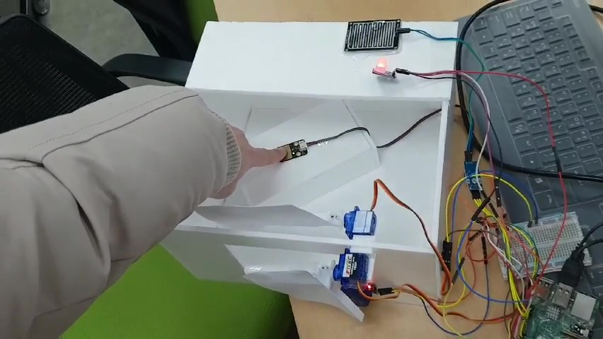System Programming

Team Project

-Group 3-

201620894, Software, Yeongyo Kim

201720706, Software, Jinwon Jung

201320878, CyberSecurity, Yongchae Park

201320919, CyberSecurity, EunChong Kim

Contents

1. Project’s motivations and goals
2. Implements & Changes
3. Distributing roles
4. Scenario, algorithm

4.1 when touch not detect rain not detect illumination not detect

4.2 when touch not detect rain not detect illumination detect

4.3 when touch detect rain not detect illumination not detect

4.4 when touch detect rain not detect illumination detect

4.5 when touch not detect rain detect illumination not detect

4.6 when touch not detect rain detect illumination detect

4.7 when touch detect rain detect illumination not detect

4.8 when touch detect rain detect illumination detect

1. Overall lesson learned
2. Update

1. Project’s motivations and goals

All four of our team members live on their own. The first thing we wanted to do with home IOT was motivation. When I was sleeping in bed during the day, I thought of curtains that would automatically cover the sun, windows that would close automatically when it rained, and alarms that would not be heard if I woke up before the alarm went off.

After compiling the sensors and the team's opinions, we can detect rainwater, light, and gas (fine) and automatically move windows and curtains depending on whether or not there are people on the bed.

1. Distributing roles

We decided to divide six types of sensors in half and make three sensor kernel modules each 2 groups. Gas, Rain, LED, Report and rehearsal for Yongchae, Eunchong group, Servo, Touch, presentation Light for Yeongyo, Jinwon group.

In this process, the gas sensor cannot work converting analogue signals into digital signals, because of limits of coding ability Yongchae, Eunchong group, so We proceeded to the remaining five sensors except for the gas sensor. After kernel modulated, Jin won Jung could synthesize all the code, and then modified by a small amount of code together.

1. Implements & Changes

We made all the sensors into kernel modules. Servo motor is controlled by the period of the pwm. RGB_led is controlled by two input values. One is color, and the other is on/off. And remaining sensors read the binary values from the kernel modules

1. Scenario, algorithm
   1. when touch not detect rain not detect illumination not detect

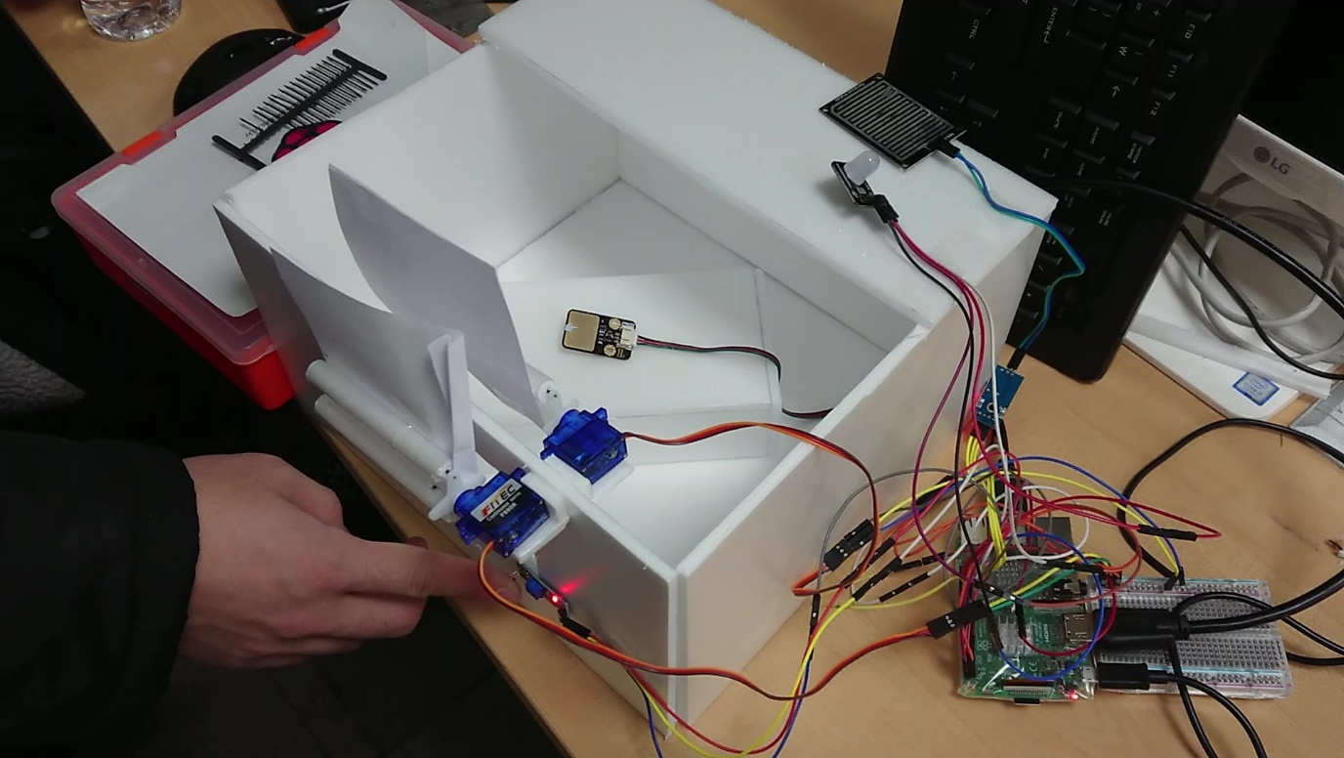

* 1. when touch not detect rain not detect illumination detect

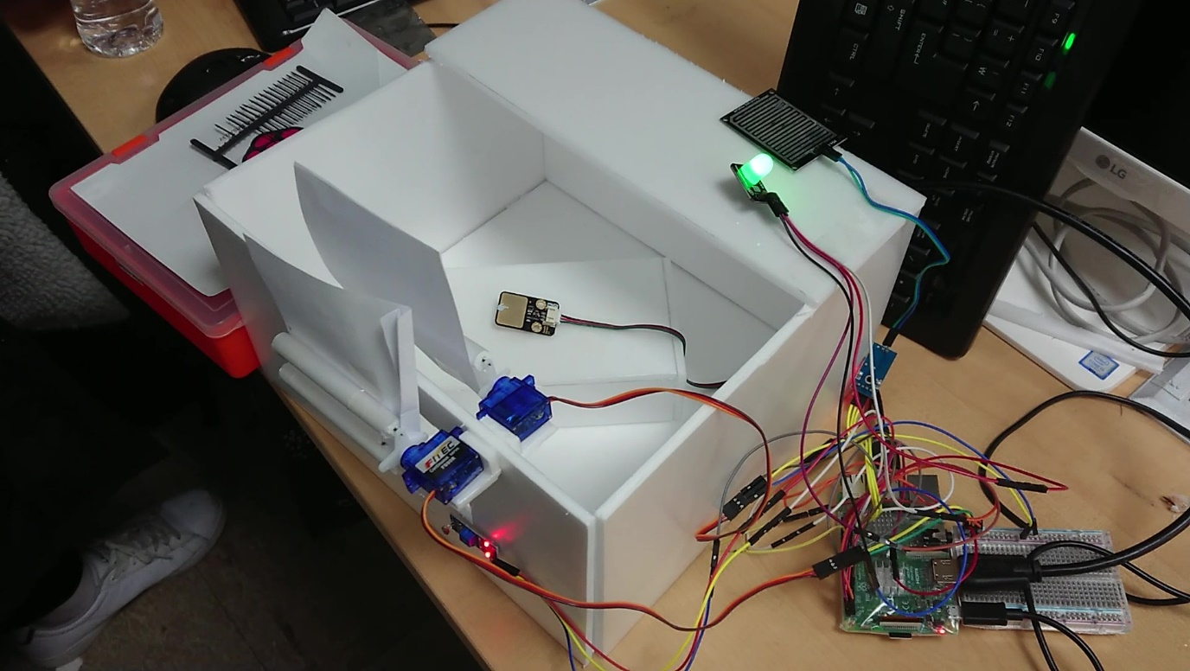

* 1. when touch detect rain not detect illumination not detect

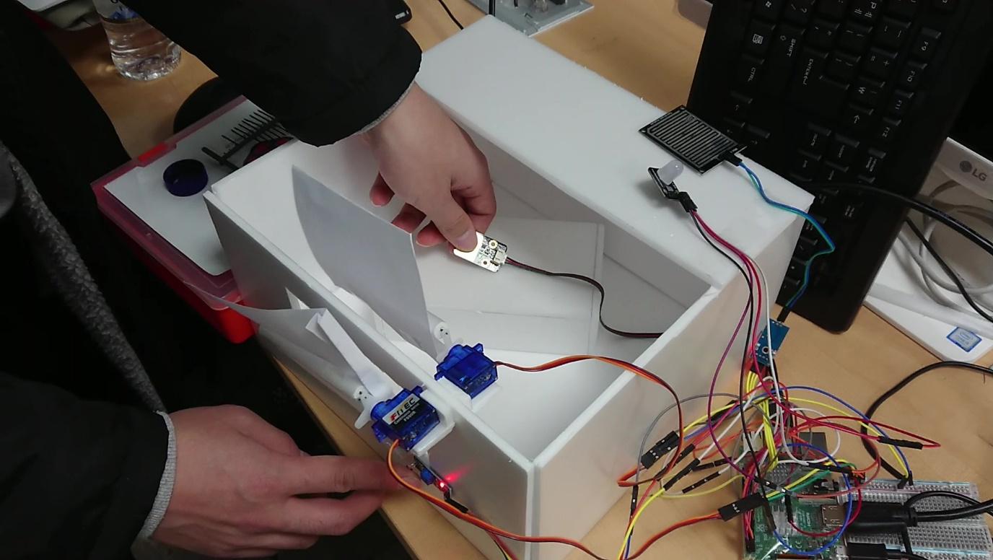

* 1. when touch detect rain not detect illumination detect

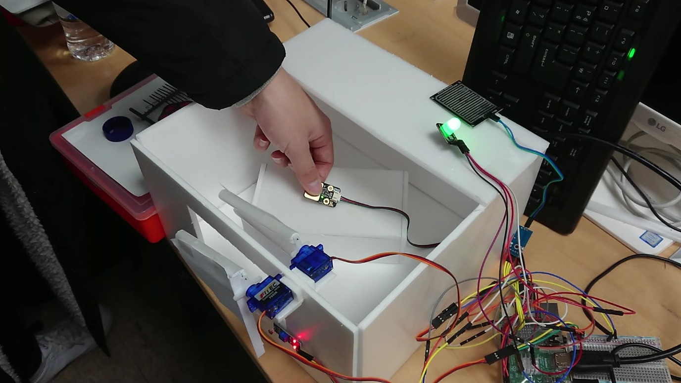

* 1. when touch not detect rain detect illumination not detect

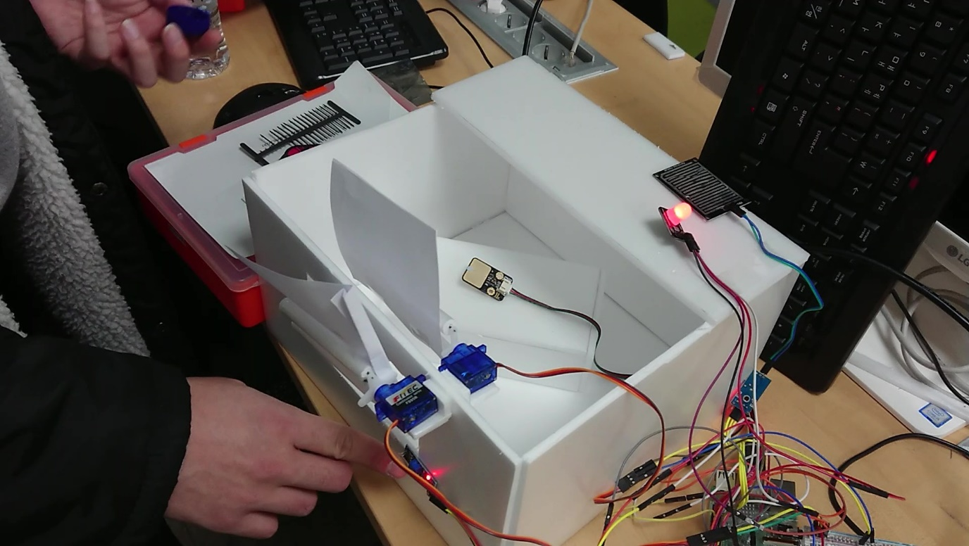

* 1. when touch not detect rain detect illumination detect
  2. when touch detect rain detect illumination not detect



* 1. when touch detect rain detect illumination detect

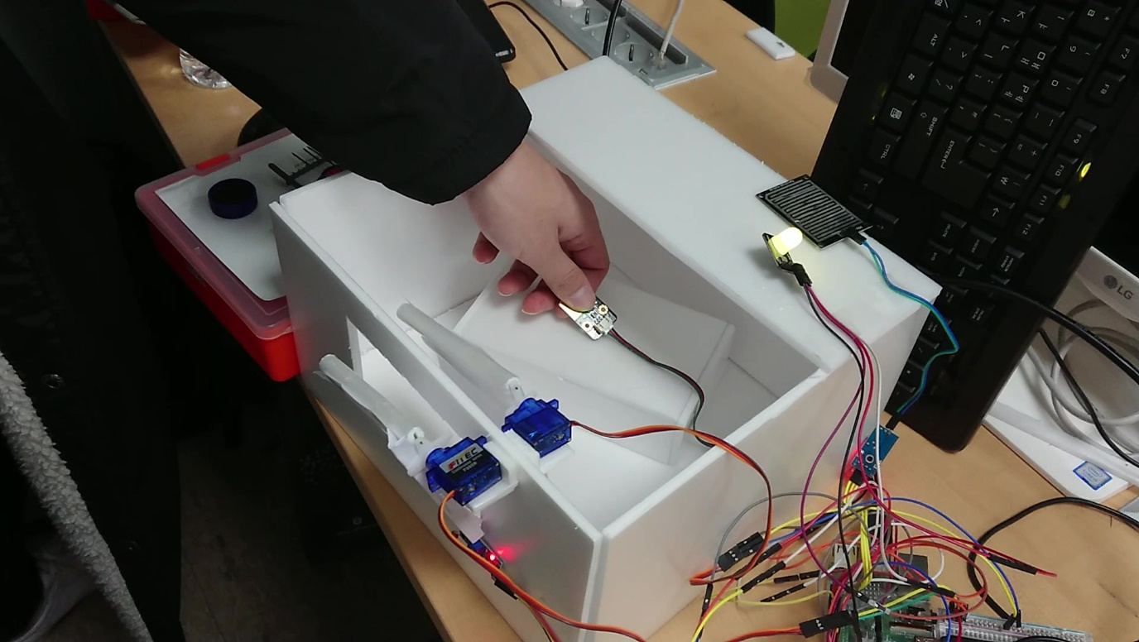

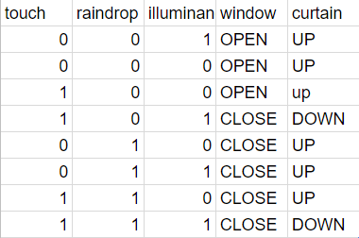

We made these sensors and curtain windows work to above condition.

1. Overall lesson learned

Raspberry Pi can’t read analog signal unlike to Arduino. So we should convert data by hard coding. but Raspberry Pi has much of open-sourced library so we could easily implement various sensors and actuators.

In Raspberry Pi RGB_led sensor’s value is reverse, if input value 1 -> off and 0 -> on

Servo motor’s pwm period is 1500, 1000, 2000 but 1500 is not accurate. We guess the reason, it’s delay for between to sensor to sensor, or value communication and so on.

1. Update

The professor pointed out a process that does not work when the sensor is missing and I modified it in the code. The first reason for this work is that when you run the code, you start with the values of each sensor initialized to zero. To fix that problem we check to gpio_get_value function. But that function cannot catch the error. In gpio_direction_input function, If initialized option change to fail, cannot read the value and print out error, but this also has the problem of not being able to check if the sensor is plugged in properly. In this time we cannot have enough time to check this problem. Maybe next when we have more time we will solve this problem. thanks to read our report.